Image | 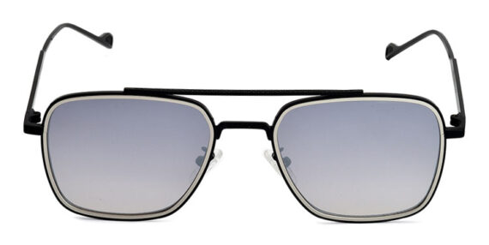
Brand | TOM FORD
Model Name | Rocko
Price | RS 1800
PRODUCT DETAILS

